Norfolk County Council (Wereham)
Emergency Notice

Temporary Traffic Regulation Order 2025
Section 14(2) of the Road Traffic Regulation Act 1984

Wereham (WTRO5802) Notice

In accordance with the provisions of Section 14(2) of the Road Traffic Regulation Act 1984, the Norfolk County Council HEREBY GIVE NOTICE that owing to electrical works the use by vehicles (of any class) of The Row from 55m south of its junction with Stoke Road for 680m southwards (the “Road”) in the Parish of Wereham will be temporarily prohibited/restricted.

Alternative route is via: The Row, Wereham Row, Flegg Green, Lynn Road, Stoke Road.

The closure/restriction is necessary because of the likelihood of danger to the public or serious damage to the road or both.

The closure/restriction is anticipated to take place from 4th to 11th April 2025 but the Road may continue to be closed/restricted until the 24th April 2025 where the closure/restriction is still required beyond the anticipated dates.

This Notice shall automatically revoke on the completion of the works / when the closure/restriction is no longer necessary or otherwise on the 24th April 2025 without further notice.

If necessary, this Notice may be extended for an additional 21 days by further Notice and/or for a maximum of 18 months from the date this Notice is effective by further Order.

The works promoter for this restriction/closure is: UK Power Distribution.

A person who contravenes, or who uses or permits the use of a vehicle in contravention of the restriction/ closure imposed by the Order shall be guilty of an offence.

Penalty: £1000 maximum fine on conviction and/or endorsement for contravention.

Full details on the closure are available at https://one.network. Any enquiries that cannot be answered on the one.network website should be directed to the West Area Streetworks (Community and Environmental Services Department) contactable by telephone at 0344 800 8020 or email at streetworks@norfolk.gov.uk

Dated this 4th day of April 2025.

Katrina Hulatt
Director of Legal Services (nplaw)
County Hall
Martineau Lane
Norwich
NR1 2DH

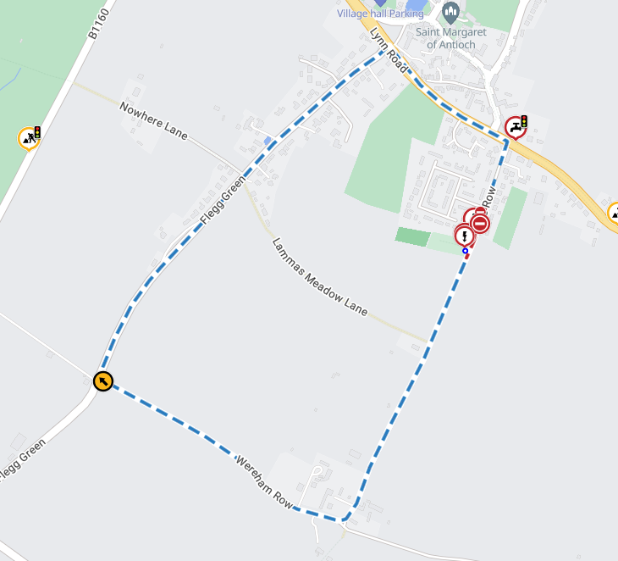
Map data © MapTiler © OpenStreetMap contributors

